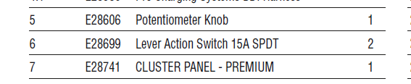

Lever action Switch E28833
E28833 | Switch, Waterproof Lever Action, IP67

